VPC – CHALLENGE

Use Case: Setting up Transit Gateway and VPC Endpoints for a Multi-VPC Architecture
Scenario:
A large organization is migrating its on-premises infrastructure to the AWS cloud.
The organization's architecture involves multiple VPCs for different departments and applications, each requiring secure communication with centralized services and external resources.
The IT team needs to design and implement a scalable and efficient network architecture to accommodate the organization's growth and ensure robust connectivity between VPCs and external services.
Objectives:
- Design and deploy a scalable network architecture using AWS Transit Gateway to simplify network connectivity between multiple VPCs.
- Configure VPC endpoints to securely access AWS services without internet gateways or NAT gateways, ensuring data privacy and minimizing exposure to external threats.

First part :
- Design and deploy a scalable network architecture using AWS Transit Gateway to simplify network connectivity between multiple VPCs.

Set up a VPC Transit Gateway.

Steps
Create 3 -VPCs : my-vpc-01 -----(10.0.0.0/24)
my-vpc-02 -----(10.0.1.0/24)
my-vpc-03 -----(10.0.2.0/24)
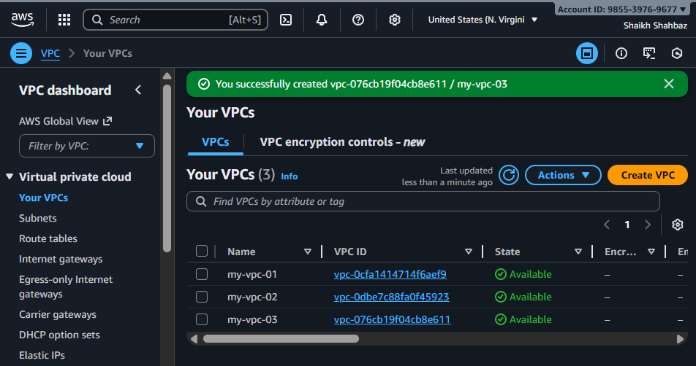

Create 3-Subnets : subnet-01 subnet-02 subnet-03
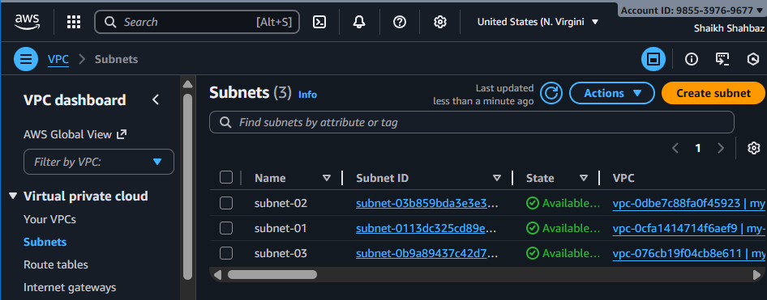

- Go to Transit Gateways → Create transit gateway
  - Name: my-tgw
  - ASN default fine → Create
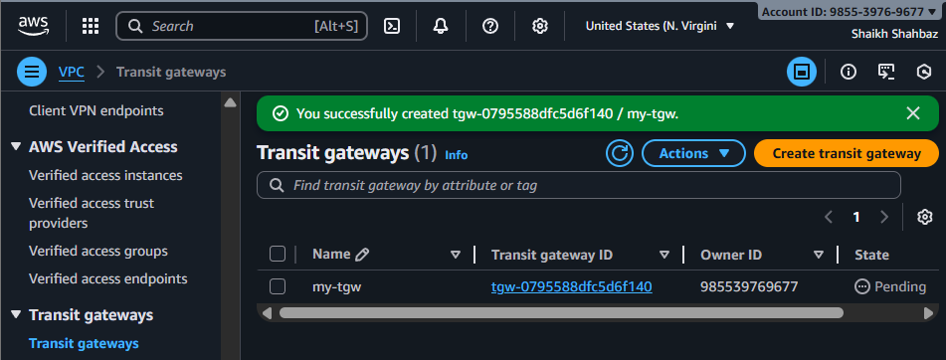
- Add TGW attachments
For each VPC:
  - Transit Gateway Attachments → Create attachment
  - Attachment type: VPC
  - Select VPC + Subnets required
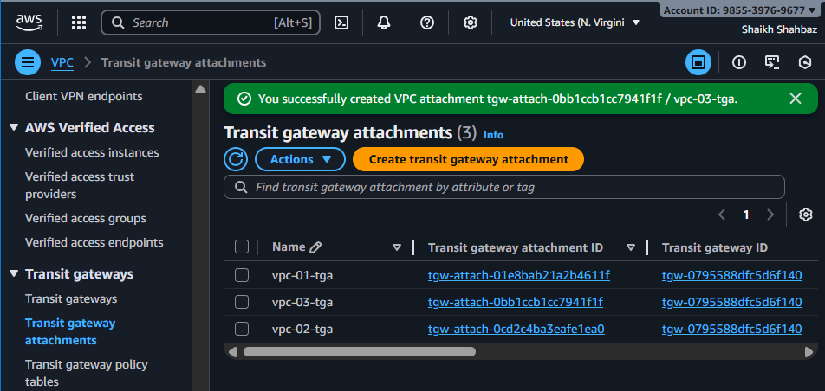

Launch 3 – Instances in public-ec2 : ec2-vpc-01 ec2-vpc-02 ec2-vpc-03
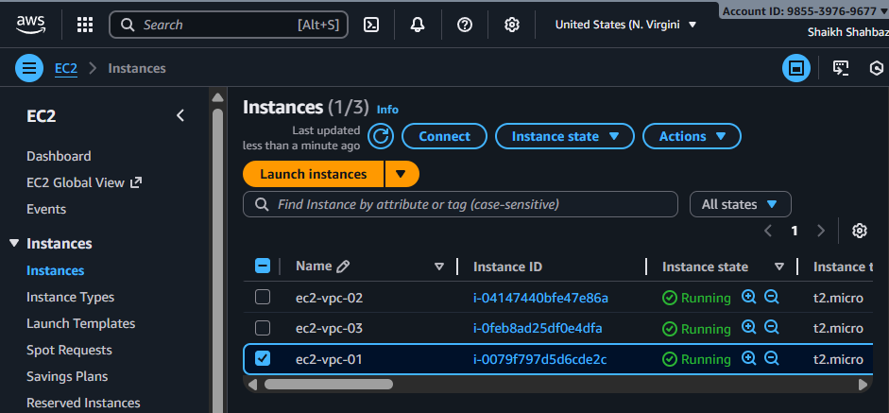

- Route Tables
  - TGW creates its own route table
  - Add routes to allow VPC CIDRs
  - In each VPC route table:
    - Add route → CIDR of other VPCs → Transit Gateway
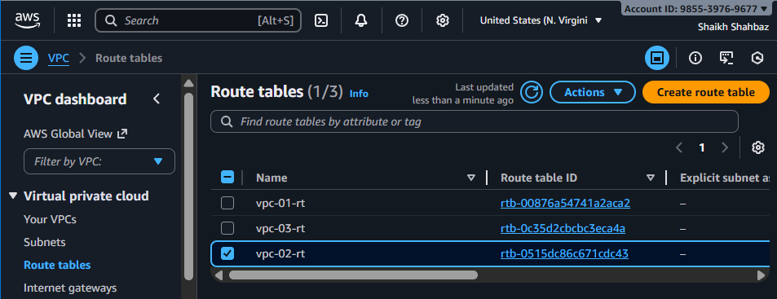
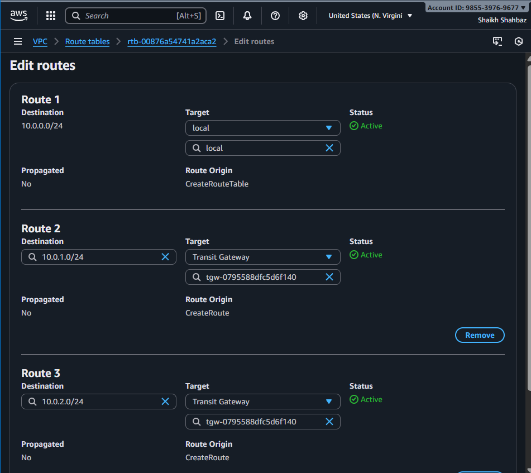

Create Internet Gateway : vpc-01-igw vpc-02-igw vpc-03-igw
Attach to the respective VPCs
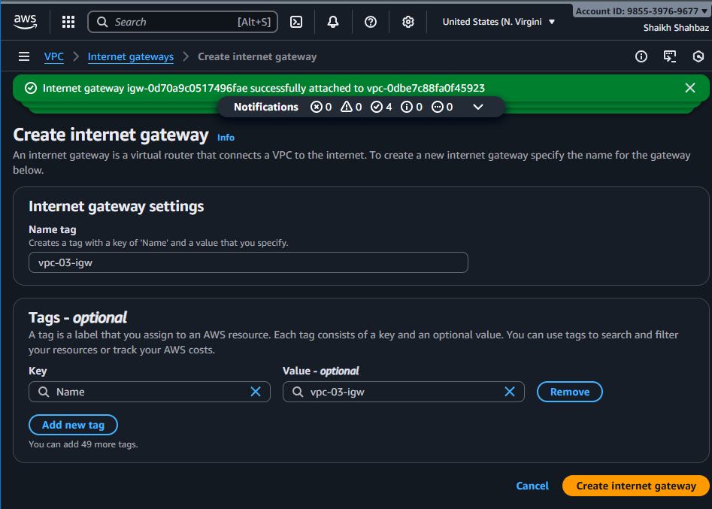
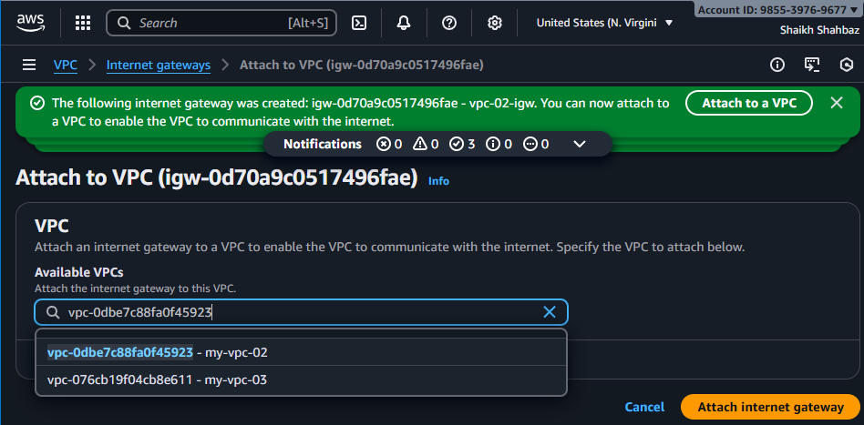
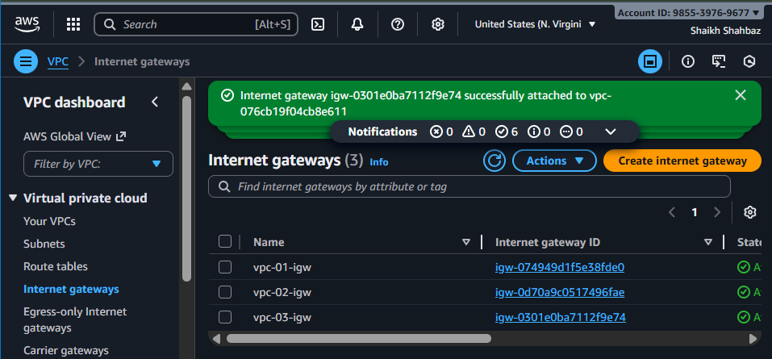
Add Internet Gateway to the Route Tables for each of them ----All – 3
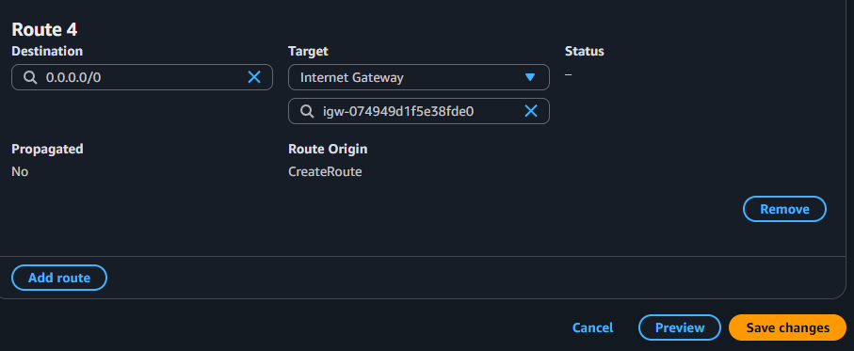
Now we can access any ec2 with its public-ip
I have connected to ec2-vpc-01 instance and ping <private-ip> of ec2-vpc-03
Its connected successfully
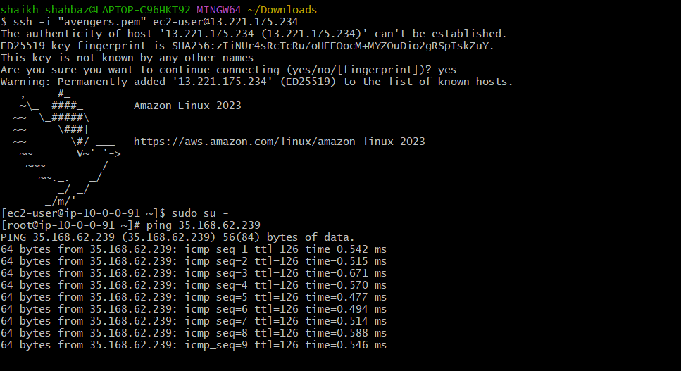

Second Part :
- Configure VPC endpoints to securely access AWS services without internet gateways or NAT gateways, ensuring data privacy and minimizing exposure to external threats.

Allows private access to AWS services without Internet.
Steps
- Go to VPC Endpoints → Create Endpoint
- Choose AWS Service — Example:
  - com.amazonaws.<region>.s3
- Type:
  - Gateway endpoint → for S3 - bucket
  - Interface endpoint → for other services (SNS, SQS, etc.)
- Select your VPC + Route tables (for gateway) or Subnets + SG (for interface)
- DNS enabled → Yes
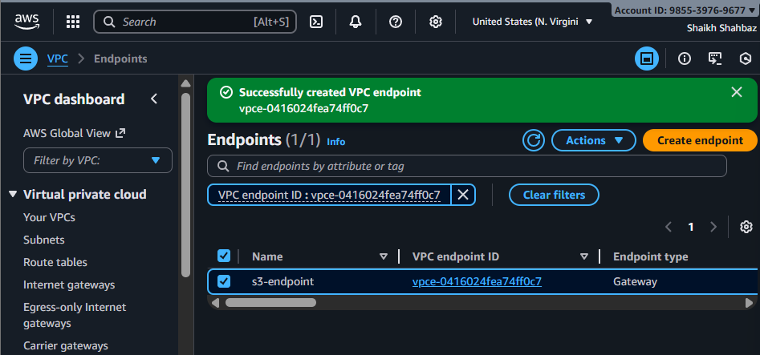
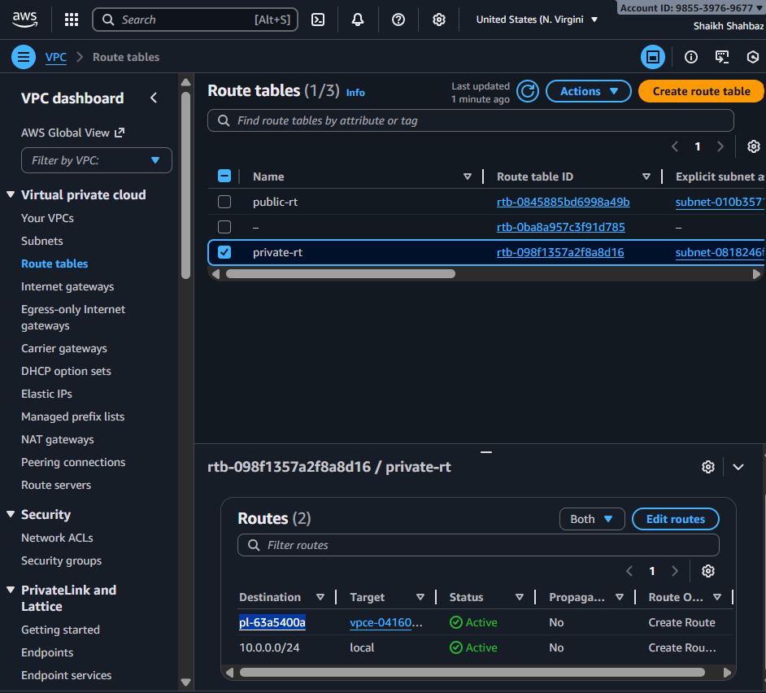

After creation:
To connect with the private ec2 we need to configure :
aws configure : from aws accon credentials create key then provide below
provide access key :
provide secret key :
provide region : us-east-1
provide format : jason
- EC2 inside private subnet can access AWS services without NAT Gateway / public internet.
After connecting the public-ec2 in gitbash we need to connect to the private-ec2
So that we need to create a .pem key
vi <avengers.pem>
chmod 400 avengers.pem
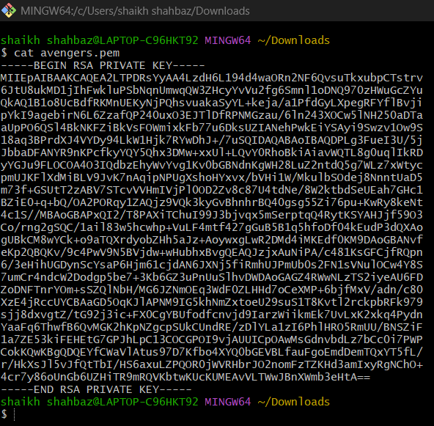
- By using ssh -I avengers.pem ec2-user@<private-ec2-private-ip>
- From public-ec2 to private-ec2 by using <private-ip>
